**BUSINESS CASE TO MICROSOFT ON A PROPOSAL TO VENTURE INTO MOVIES CREATION**

**INTRODUCTION**

Microsoft intends to venture into a new field of movie creation by establishing a movie studio.

The business environment is constantly changing owed to major innovations and the entry of new competitors in virtually all business fields. This dynamism and competition in the business landscape have brought out the need for corporates to re-think their strategies and re-engineer their business functions to remain competitive, technologically up to date, diversify income streams and stay ahead of the curve.

Microsoft is no exception. This project recognizes the need for Microsoft to maintain its market leadership and diversify to other business areas so as to maintain its market leadership and meet customer demands.

**PURPOSE OF THE PROJECT**

The purpose of this business case is to provide Microsoft with compelling reasons why the company should create a new movie studio and venture into the movie production business.

Data from IMDB datasets will be utilized to determine the trends in the movie business world in terms of genres, runtimes, and production per year among other factors Microsoft should put under consideration as they plan to invest in the new venture.

**BUSINESS PROBLEM/OBJECTIVES OF THE PROJECT**

Microsoft wants to venture into the world of movie production and owing to the fact that they have no prior experience in the area a decision has to be made on viability, trends, market and other factors that will assist the management make the decision. This project will explore the data in the movie world and identify movies that are performing well and translate the data into actionable information that will help Microsoft venture into the new world of movie creation.

Major areas of consideration will be the most popular movie genre types, runtime, and movie production trends over the years among others that will enable Microsoft to make the decision on whether to venture into the movie business or the contrary.

**SCOPE AND APPROACH**

* Movie datasets from IMDB have been used and specifically imdb. title.basics analyzed using Python programming language.
* The data consist of movie titles, genres, runtime, and year of movie creation
* The below information has been deduced from analyzing the data;

1. Genre popularity
2. Average runtime in minutes per genre
3. Number of movies produced over the years, and
4. Movie translations from one language to another

* Charts, graphs, and other visualizations have been provided

**FINDINGS**

1. **GENRE POPULARITY**

* Data from IDMB indicates that Drama, Documentary, and comedy were the most popular genre types.
* For Microsoft to venture into the market the information is critical to ensure that there is demand for its movies.

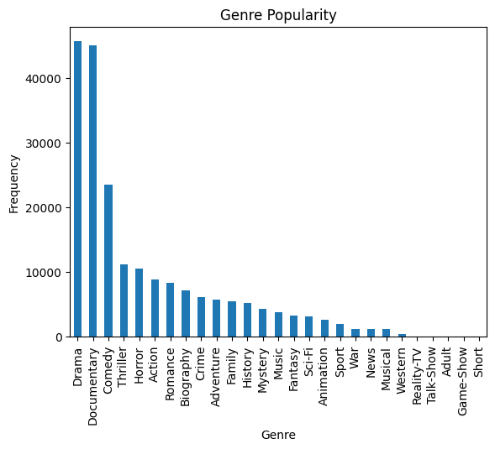

1. **MOVIE RUNTIMES IN MINUTES**

* Data indicated that most movies had a runtime of about 86 minutes
* Runtimes less than and more than the 86 minutes were unpopular

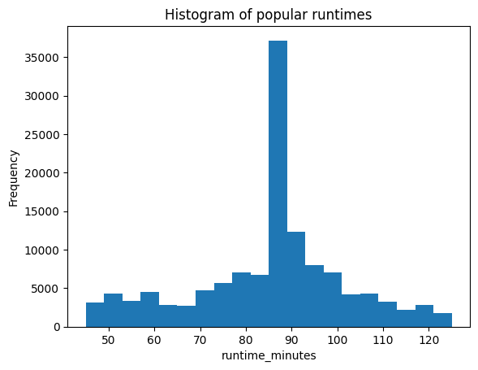

1. **YEARLY MOVIE PRODUCTION GROWTH**

* The trend of movie production showed consistent growth from 2010 to 2018.
* There was a slump after 2018 mainly due to the global pandemic that affected all industries across the globe

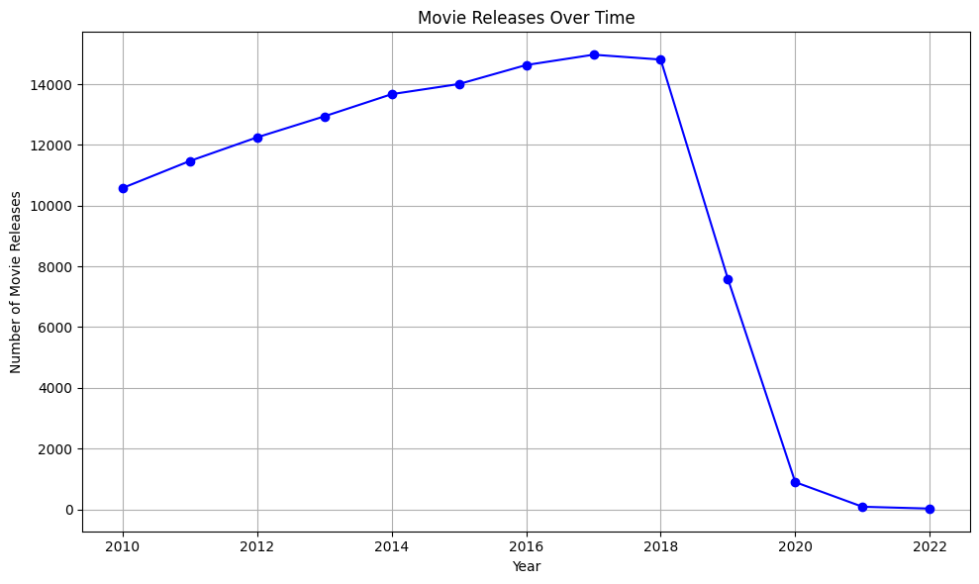

1. **TOP MOVIES BY RUNTIME IN MINUTES**

Below were the top 10 ten movies by runtime minutes.

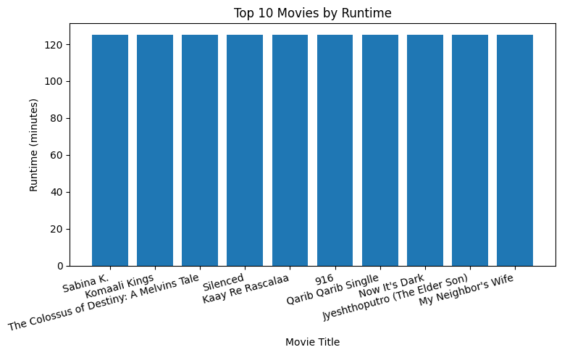

1. **MOVIE TRANSLATION**

From the data only 10.5% of the movies were translated from one language to another as shown by the pie chart below.

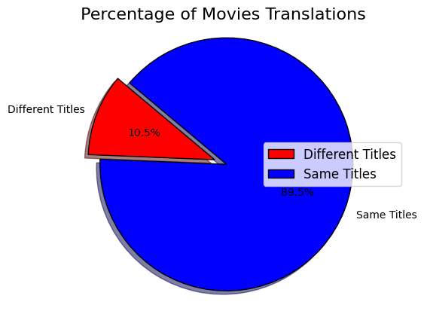

**RECOMMENDATIONS TO MICROSOFT**

* 1. There has been a general increase in movie production over time except for the period after 2019 which was occasioned by a decline in movie creation caused by the Covid-19 pandemic.

This is an indicator that there is growth in the movie industry and hence Microsoft should venture into the business.

* 1. Microsoft should consider creating popular movie genres that will get demand from the market, preferably the top 5 genres. The most popular genres include Drama, Documentaries, comedies, Thrillers, and horror movies.
  2. Microsoft should consider producing movies with a runtime of around 84 minutes since this is the most popular runtime across all the movie genres.
  3. From Data analysis, there was a low translation of movies (about 10%). This means that there will be no need for investment in the area of movie translations

**CONCLUSION**

The project embarked on the viability of Microsoft venturing into the movies business. The data indicated that the popular genres were Drama, Documentary, and comedy with runtimes of around 86 minutes being popular. The data also showed consistent growth in the movie production over time save for 2019 to 2021 where there was a sharp decline brought about by the global Covid-19 pandemic.

I recommend Microsoft to venture into the popular genres for market viability in order to divert incomes.